Jeffrey Razon

Argenis Jimenez

CPE 403-1001

NSHE 2000718323

CC1350 Lab 5

Github root directory: https://github.com/JeffinVegas/403_AdvEmbSys

Date Due: November 24th, 2018

**Task 1**: Building and loading the collector example

- We successfully built and load the collector example onto one CC1350 device.

**Task 2**: Building and loading the sensor example

- We successfully built and load the sensor example onto one CC1350 device.

a) The PuTTY output for the collector and sensor examples

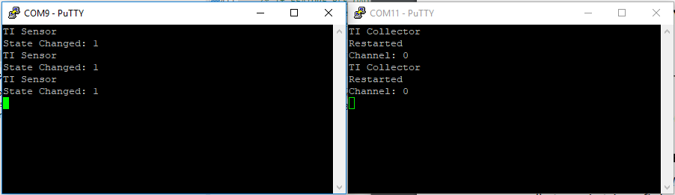

**Task 3**: Using the Collector and Sensor

- We successfully used the two CC1350 device with the collector/sensor examples to interact with each other.

**Task 4**: Updating the sensor's reporting rate

- We successfully changed the reporting interval for the sensor example and the reporting/polling interval for the collector example, then built and loaded the examples.

Youtube Link: https://youtu.be/d2y9b-VP6-Y